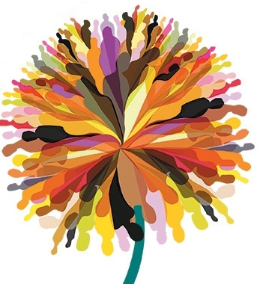**European contest: Narrating the Dialogue**

The contest “Narrating the Dialogue” aims to collect narrations of experiences of intercultural dialogue in Europe.

These experiences can be the most diverse, like:

- educational projects aimed to fight racism and xenophobia;

- social actions and campaigns promoted by activist, migrants and citizens in general, aimed to create mutual knowledge, and cooperation between people from different cultures;

- personal experiences, related to the challenge of overcoming racism and xenophobia, and foster the value of intercultural dialogue...

The authors of the stories narrated can be individuals, groups, communities, organizations.

The contest is open to various kinds of narrations:

* **Autobiography or biography**: Autobiographical narration, telling what you experienced directly in first person, or a biographical narration, if you are collecting experiences of other persons. The text, which should be no longer than ten pages, can be sent in word or PDF format.
* **Photo narration** (text and pictures): a narration that’s composed of pictures accompanied by texts. It may be an autobiographical narration, telling what you experienced directly in first person, or a biographical narration, if you are collecting experiences of other persons. The text, which should be no longer than ten pages, can be sent in word or PDF format.
* **Video narration**: you can tell the story through diverse types of video narration, such as documentary, video interview, digital storytelling or any other creative form. Maximum length ten minutes.
* **Comics**: tell a lived experience of intercultural dialogue through the comics. Maximum ten folders length.

**HOW TO SEND THE STORIES**

In order to participate in the contest, send your story in a word document to the following email address: [berlinlampedusa@gmail.com](mailto:berlinlampedusa@gmail.com). For the participation, please fill in and send back the Application Form. The Application Form can be downloaded from the Facebook profile of the Oltalom Charity Society :

(<https://www.facebook.com/oltalom.karitativegyesulet/>).

**GENERAL INFORMATION**

**AUTHORS:** the narration can be realized by individuals, informal groups, communities, organizations.

**LANGUAGES**: it’s possible to participate in the following languages: English, French, Italian, Polish, Hungarian, Romanian, Spanish, German, Greek. The English translation, or subtitles in case of video narration, is welcomed but not mandatory.

**NUMBER OF STORIES**: the authors can participate sending one or more stories.

**DEADLINE**: the deadline to send the story(s) is October 20th, 2017.

**SELECTION AND AWARDS**: a first level of selection will be done at a national level, according to the languages of the stories, and will come to the choice of four finalists for each language (one for each narration category).

A second level selection, run by an international giury, will select four winners among the finalists (one for each narration category).

The stories (finalist and winners) will be collected in an handbook of good practice.

A representative for each of the winning projects will be invited to the final event of the project in Strasbourg (15-17/03/2018).

The contest is part of the project **Lampedusa Berlin, Travel journal. Europe for Citizens** **Program** – Strand2: Democratic engagement and civic participation. 2.3: Civil Society Project (project: 577736-CITIZ-1-2016-1-IT-CITIZ-CIV).

The project aims to develop the discussion among European citizens on some key issues for Europe today, in relation to migration crisis:

- How to develop better migration policies in Europe?

- How to put a barrier to the spread of xenophobic and racist attitudes and visions?

- How to develop intercultural dialogue in Europe?

**Partners**: Fondazione ForTeS (Italy, coordnator), Asinitas Onlus (Italy), Sosrazzismoitalia (Italy), Sozial.Label E.V. (Germany), S.O.S. Racismo Gipuzkoa Asociacion (Spain), Egam-European Grassroots Antiracist Movement Association (France), Oltalom Karitativ Egyesulet (Hungary), Asociatia Tineri Parteneri Pentru Dezvoltarea Societatii Civil (Romania), International Centre For Sustainable Development (Greece), Towarzystwo Amicus (Poland).

**Contacts**: [berlinlampedusa@gmail.com](mailto:berlinlampedusa@gmail.com)

**Web site**: [www.lampedusaberlin.eu](http://www.lampedusaberlin.eu)

In the cover: painting of Azadeh Ramezani Tabrizi